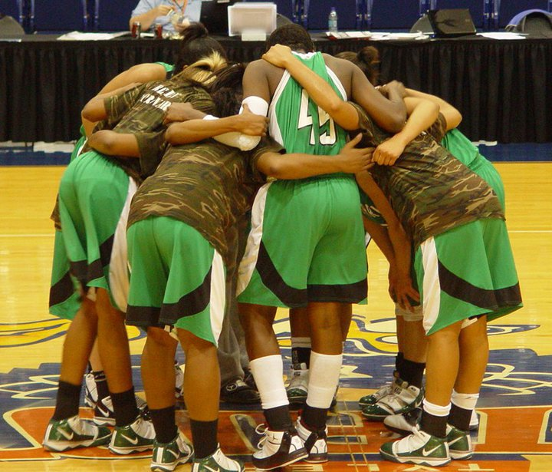
Sign up TODAY to reserve your spot at camp!
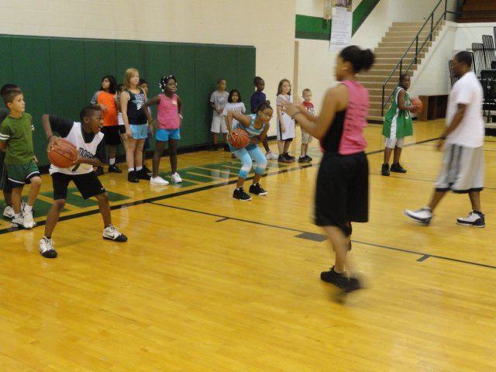
Check Your Event
- Session 1 $ 45
- Session 2 $ 45
- Full Day Camp $ 80
- Overnight Camp $ 150
- Team Camp $ 350
- Join the Cub Club $ 25
Name_____________________________________________
Address___________________________________________
__________________________________________________
Phone_____________________________________________
E-mail_____________________________________________
School_________________________________Gender_____
Grade as of Fall 2012_____Age_____T-Shirt Size_________
How did you hear about camp? ________________________
Team Camp Only:
Team Name _______________________________________
Coach’s Name ___________________Phone_____________
Method of Payment – Made out to Brenita Williams
- Check (Drivers License # & DOB on checks)
- Money Order
- Credit Card#___________________________________
Visa______ MasterCard______ Discover______ Exp.Date________Sign_______________________________
Liability Waiver
I ______________________________, hereby certify that I am the parent/legal guardian of the camper listed. I hereby give my permission to seek appropriate medical attention in the event of an accident, injury or illness. I will be responsible for any and all costs of medical treatment and release forever Lon Morris College and the camp, its staff, and representatives from all rights and claims for damages that arise out of participation in the camp.
Signature__________________________________________
Date______________________________________________

Camp Information
Dates: June 11-14, 2012
Individual Camp
Session 1 8:00 am – 12:00 pm Breakfast Included $ 45
Session 2 12:00 pm – 5:00 pm Lunch Included $ 45
Full Day Camp 8:00 – 5:00 Breakfast & Lunch Included $ 80
Overnight Camp All Meals Included $150
Check in Sunday June 10; check out Thursday June 14

Team Camp
This Camp is open to AAU, Varsity and Junior Varsity teams to participate (Ages 13-18). Teams of 7-10 players per team may register. According to UIL rules, head coach must designate a volunteer coach for the week. All meals are included; teams will stay overnight on campus. Players will go through the individual skills camp during the day. Campers will play games during evenings. Great for team bonding! Team Cost: $350

IMPORTANT INFO:
- Registration begins at 7:30 am on Monday-June 11
- Space and supplies are limited; Pre-register to secure your spot and supplies for camp!
- Any cancellations require a $25 fee
- Overnight Campers should bring:
  - Comfortable Workout Clothes for 5 days
  - Twin size sheets
  - Towels
  - 2 rolls of tissue
  - Toiletry items (soap, deodorant etc.)

Overnight Campers must pre-register by June 1st

For more info contact Camp Director:
Brenita Williams
903-589-1404
bwilliams@lonmorris.edu

This camp was designed to give players an opportunity to develop skills, confidence and commitment in order to be successful both on and off the court. Campers will enjoy the 7:1 camper to staff member ratio to promote a positive learning environment that embraces competition as well as good sportsmanship.
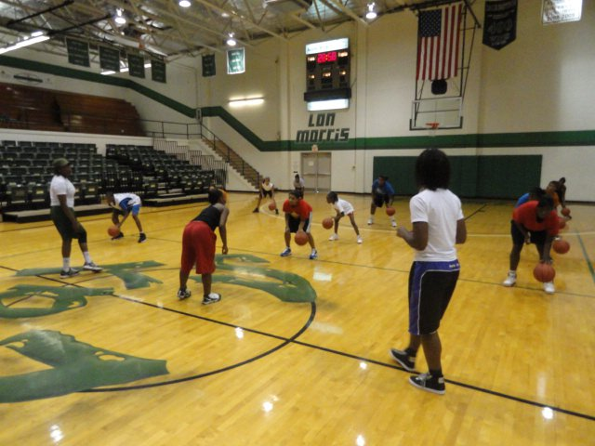
Camp Features:
- Camp T-Shirt
- Just Maximizing Potential Wristband & Bag
- Flexibility Exercises
- Competitions Daily
- Emphasis on Basketball Fundamentals
- Individual Skill Instruction
- Motivational Speeches
- Campers divided & Coached by age & ability

Join the Cub Club
1 year membership is $25
Open ages 8-18
LMC Basketball Jersey
20% discount on summer camp
Autographed Team Poster
Ball Boy/Girl at a home game

