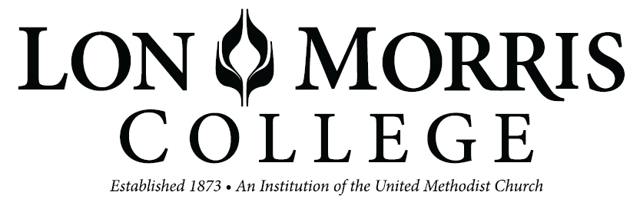

# CHECK REQUEST

WITH THE ACCEPTANCE OF THIS REQUESTED CASH ADVANCE, THE RECIPIENT UNDERSTANDS THAT ORIGINAL PAPER RECEIPTS ARE REQUIRED TO DOCUMENT THE EXPENDITURE. IT IS FURTHER UNDERSTOOD THAT THE FULL AMOUNT OF THE ADVANCE WILL EITHER BE “BACKED-UP” WITH RECIPTS OR RETURNED FOR CREDIT.

## DATE:       ACCT.TO CHG.:

## AMOUNT:       NEED CHECK BY:

**PAYABLE TO:**

**DATE OF DEPARTURE:** **TIME:**

**DESCRIPTION OF USE OF FUNDS WITH DETAILS:**

### REQUESTED BY:       DATE:

**APPROVED BY:**

**ADMINISTRATION APPROVAL:**

**DATE:**